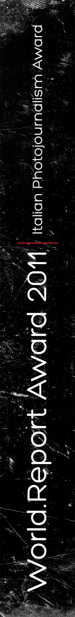
application form

Name & Surname: .....................................................................................
Place and Date of Birth: ..............................................................................
I.D.: .........................................................................................................
Occupation: ...............................................................................................
Address: ...................................................................................................
Postal Code:................. City/Town: ......................... County: ....................... State.......................................... Nationality: .............................................
Phone: ....................................... Mobile: ...................................................
Email: .......................................................................................................
Web: ........................................................................................................
Short Bio: .................................................................................................
................................................................................................................
................................................................................................................
................................................................................................................

Title of the Photographic Project: .................................................................
Location and Duration of the Project: ............................................................

Herewith I declare and accept the following:
• I am the author of the images submitted for the award
• I own the copyright of the images submitted
• I am authorized by the subjects pictured in the images to the use of the same and I take on full responsibility for it
• Should I be granted with the award, I will transfer to the Festival of Ethical Photography and Artèfoto | International Festival of Photojournalism the rights for the use of the images for promotional and communication purposes related to the festivals, the award, the prize giving and the launch of the next editions of both the Award and the Festivals or for any other purpose related to the World. Report Award programme both online and offline.
• I will authorize the use of the images that compose the awarded reportage for an exhibition that will be presented during the Festival of Ethical Photography of Lodi and Artèfoto | International Festival of Photojournalism of the province of Ancona in the editions 2011 and in other locations suitable to give the maximum visibility to the awarded reportage until 31st December 2011
• I certify that I have read, understood and accepted all the World. Report Award application requirements and submission guidelines.

It is possible to abandon the award at any given moment by simply emailing the organizers.

The Award programme may experienced some minor changes that are independent from the organization.

This application form is to be filled by the applicant and added to the CD/DVD.
The Award Winner must sign and return by post this application form by 25th April 2011.
Deadline for grants applications is 7th April 2011. All the material that arrives after this date will not be taken into consideration.

City/Town: .......................................... Date: ..........................................

I authorise the use of my personal data in compliance with Legislative Decree 196/2003):
The data gathered with the award will be used by the Festival of Ethical Photography and ArtèFoto | International Festival of Photojournalism solely for award purposes and will not be transmitted to any third party.
The names of the winners will be announced by the media. The organization will act under the Privacy law and the safety of personal data management.

